Date | 26 june 2026
Team ID
Project Name | Sports Hall Booking system using servicenow
Maximum Marks | 4 Marks

Technical Architecture:
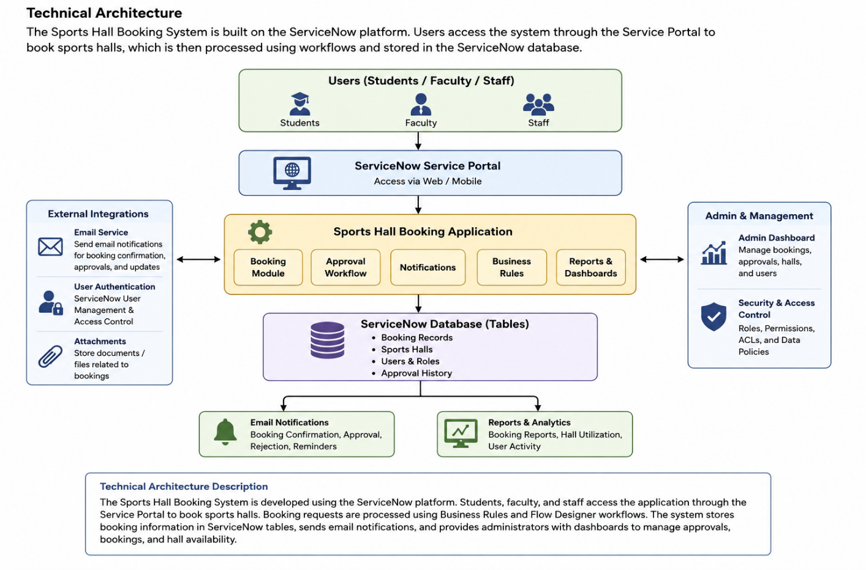
The Sports Hall Booking System is developed using the ServiceNow platform. Students, faculty, and staff access the application through the Service Portal to book sports halls. Booking requests are processed using Business Rules and Flow Designer workflows. The system stores booking information in ServiceNow tables, sends email notifications, and provides administrators with a dashboard to manage approvals, bookings, and hall availability.

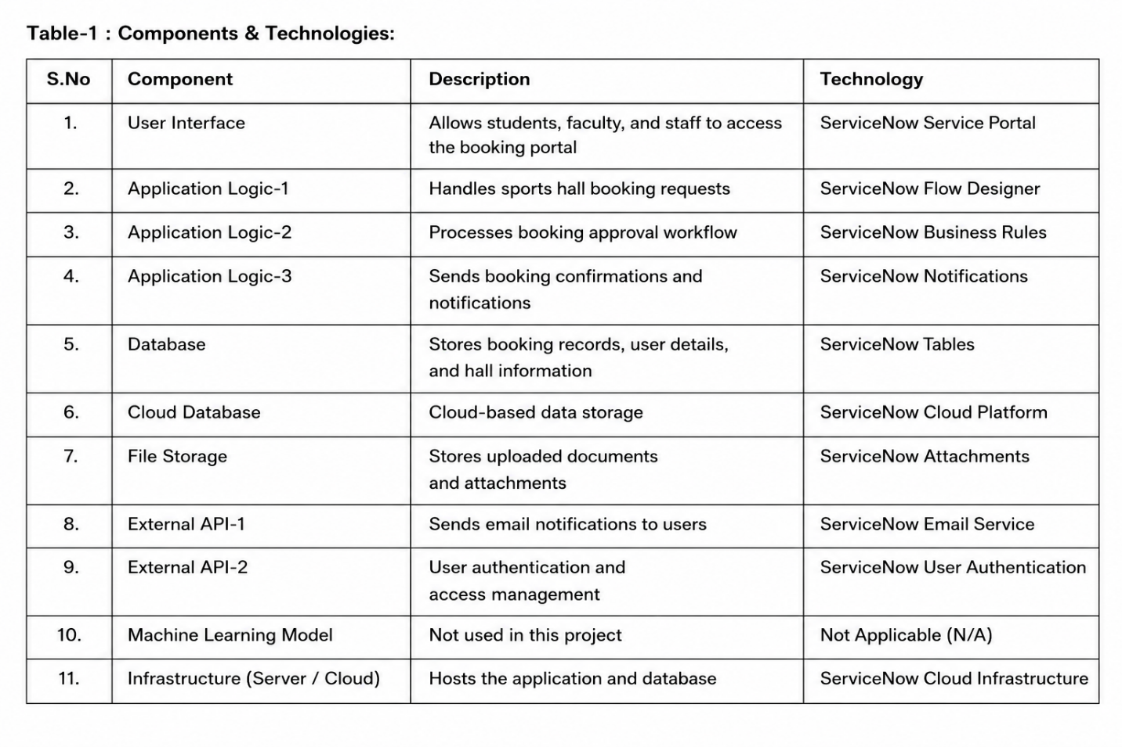
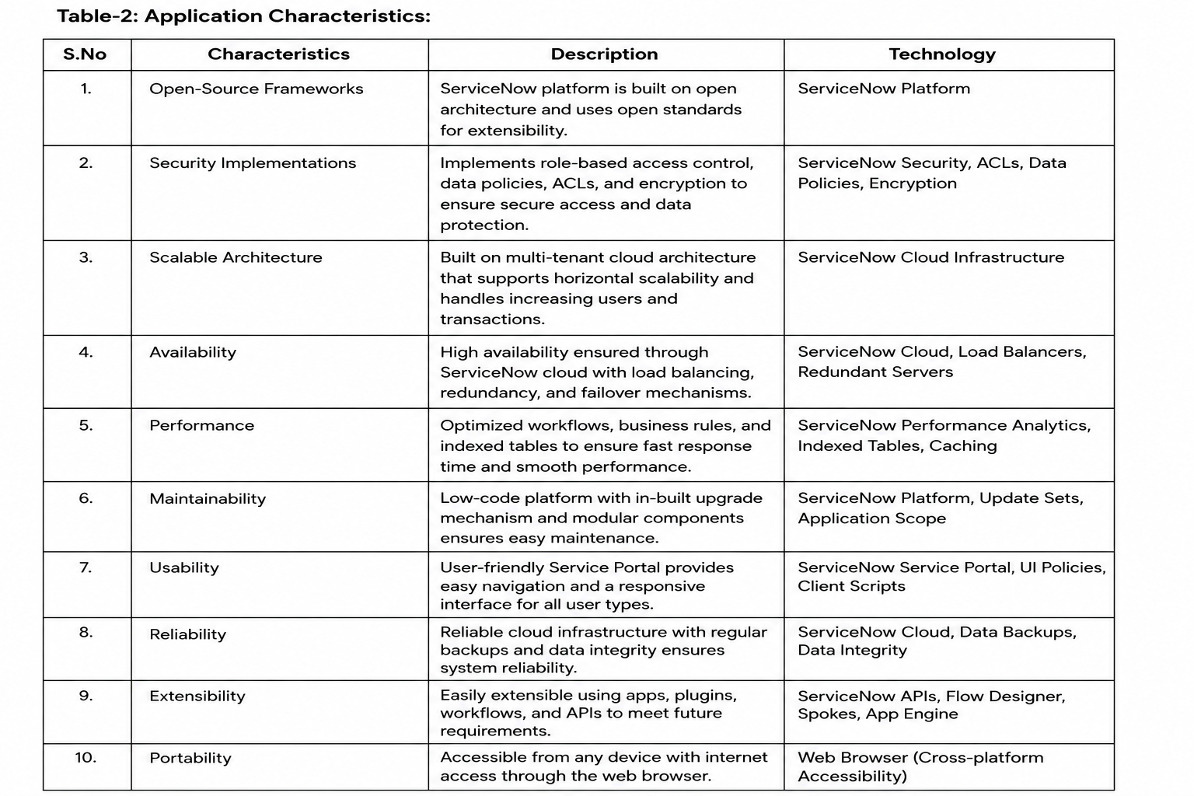
References:
https://developer.servicenow.com/
https://www.servicenow.com/products/app
https://www.servicenow.com/

